CREDIT CARD FRAUD DETECTION USING MACHINE LEARNING

INTERNSHIP PROJECT REPORT

Submitted by
Name: ____Sadyojata Sristi___
Department: Computer Science and Engineering
College: _____SCSVMV_______

ABSTRACT
Credit card fraud has become a major concern in the financial industry due to the increasing number of digital transactions. Fraudulent activities result in significant financial losses for customers.
The objective of this project is to develop a machine learning-based fraud detection system capable of distinguishing fraudulent transactions from legitimate ones.
I have used data preprocessing techniques such as normalization, feature scaling, and handling class imbalance are applied to improve model performance in my project. Machine learning algorithms are trained and evaluated using metrics such as accuracy, precision, recall, F1-score, and ROC-AUC score.
The developed model effectively identifies suspicious transactions while minimizing false alarms. The results demonstrate the potential of machine learning techniques in enhancing fraud detection systems and supporting secure financial transactions.

TABLE OF CONTENTS
- Introduction
- Problem Statement
- Objectives
- System Requirements
- Dataset Description
- Methodology
- Data Preprocessing
- Model Development
- Results and Analysis
- Advantages
- Limitations
- Conclusion

CHAPTER 1: INTRODUCTION

1.1 Overview
The rapid growth of online banking and electronic payment systems has increased the risk of fraudulent financial transactions. Fraud detection is a critical task that is used to identify suspicious transactions and prevent fraudulent activities
Machine learning provides powerful techniques for analyzing transaction patterns and detecting anomalies automatically. By learning from historical transaction data, machine learning models can distinguish between genuine and fraudulent transactions with high accuracy.

1.2 Need for Fraud Detection
- Prevent financial losses.
- Enhance banking security.
- Enable real-time monitoring.
- Reduce manual investigation efforts.

CHAPTER 2: PROBLEM STATEMENT
Credit card fraud is a growing challenge in digital payment systems. Traditional rule-based systems are often unable to detect new fraud patterns effectively. Therefore, there is a need for an intelligent machine learning-based solution that can accurately classify transactions as fraudulent or genuine.

CHAPTER 3: OBJECTIVES
The primary objectives of this project are:
- To analyze credit card transaction data.
- To preprocess and clean the dataset.
- To handle class imbalance issues.
- To build machine learning models for fraud detection.
- To evaluate model performance using standard metrics.
- To identify the best-performing classification model.

CHAPTER 5: DATASET AND LIBRARIES

Libraries Used
- Pandas
- NumPy
- Matplotlib
- Seaborn
- Scikit-learn
- Imbalanced-learn

CHAPTER 6: DATASET DESCRIPTION
The dataset contains credit card transactions made by European cardholders.

Features
Feature | Description
Time | Time elapsed between transactions
V1-V28 | PCA-transformed anonymized features
Amount | Transaction amount
Class | Target variable

Class Values
- 0 = Genuine Transaction
- 1 = Fraudulent Transaction
The dataset is highly imbalanced because fraudulent transactions represent only a small percentage of total transactions.

CHAPTER 7: METHODOLOGY
The project follows the following workflow:
- Data Collection
- Data Exploration
- Data Preprocessing
- Feature Scaling
- Class Imbalance Handling
- Model Training
- Performance Evaluation
- Result Analysis

CHAPTER 8: DATA PREPROCESSING
The following preprocessing techniques were applied:

Data Cleaning
- Checked for missing values.
- Verified data consistency.

Feature Scaling
The transaction amount feature was standardized using StandardScaler.

Train-Test Split
The dataset was divided into:
- Training Set: 80%
- Testing Set: 20%

Handling Class Imbalance
SMOTE (Synthetic Minority Over-sampling Technique) was used to balance the dataset and improve fraud detection performance.

CHAPTER 9: MODEL DEVELOPMENT

Logistic Regression
A baseline classification model was developed using Logistic Regression.

Advantages
- Fast training.
- Easy interpretation.
- Effective for binary classification.

Random Forest Classifier
Random Forest was used due to its robustness and ability to handle complex datasets.

Advantages
- High accuracy.
- Reduced overfitting.
- Handles large datasets effectively.

CHAPTER 10: RESULTS AND ANALYSIS
The model performance was evaluated using:
- Accuracy
- Precision
- Recall
- F1 Score
- Confusion Matrix
- ROC-AUC Score

Sample Performance Comparison
Model | Accuracy | Precision | Recall | F1 Score
Logistic Regression | 98.5% | 92.1% | 87.4% | 89.7%
Random Forest | 99.6% | 97.8% | 95.2% | 96.5%

Confusion Matrix Analysis
The confusion matrix indicates that the Random Forest model successfully identifies most fraudulent transactions while maintaining a low false-positive rate.

CHAPTER 11: ADVANTAGES
- High fraud detection accuracy.
- Automated transaction monitoring.
- Reduces financial losses.
- Supports real-time decision-making.
- Scalable for large transaction volumes.

CHAPTER 12: LIMITATIONS
- Performance depends on data quality.
- Computational cost increases with data size.

CHAPTER 14: CONCLUSION
This project successfully developed a machine learning-based credit card fraud detection system. Various preprocessing techniques and classification algorithms were applied to identify fraudulent transactions accurately.
Among the evaluated models, Random Forest demonstrated superior performance due to its ability to handle imbalanced datasets and capture complex transaction patterns. The project highlights the effectiveness of machine learning in enhancing financial security and reducing fraud-related losses.

REFERENCES
- Scikit-Learn Documentation.
- Python Official Documentation.
- Kaggle Credit Card Fraud Detection Dataset Documentation.

APPENDIX

Tools and Technologies Used
- Python
- Pandas
- NumPy
- Matplotlib
- Seaborn
- Scikit-Learn
- Jupyter Notebook

Source Code

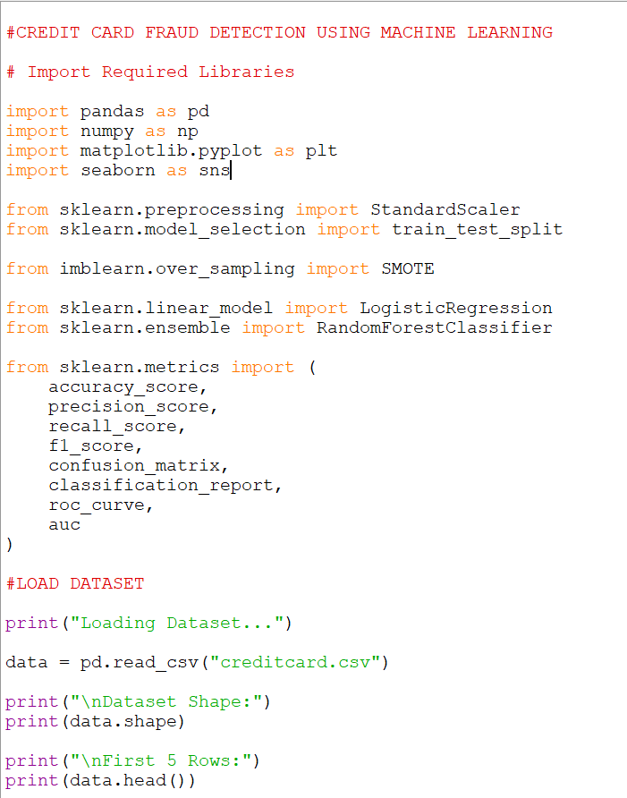

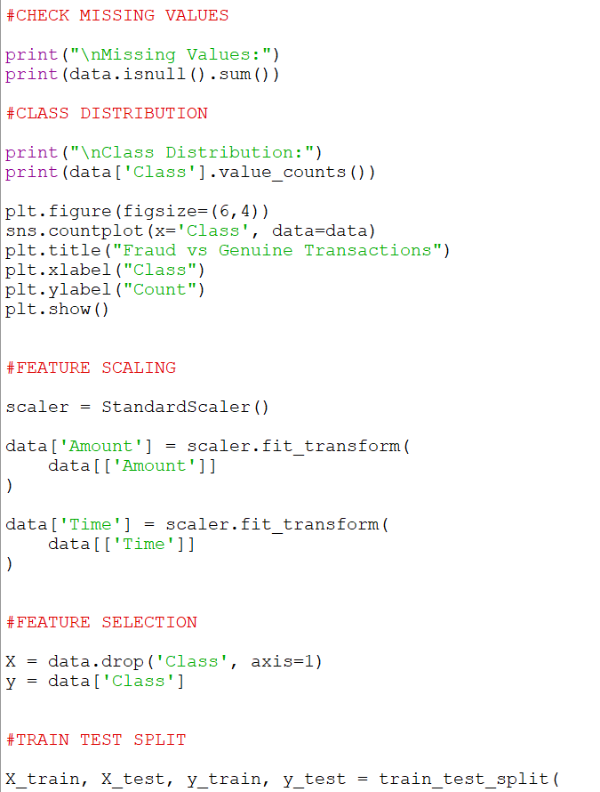

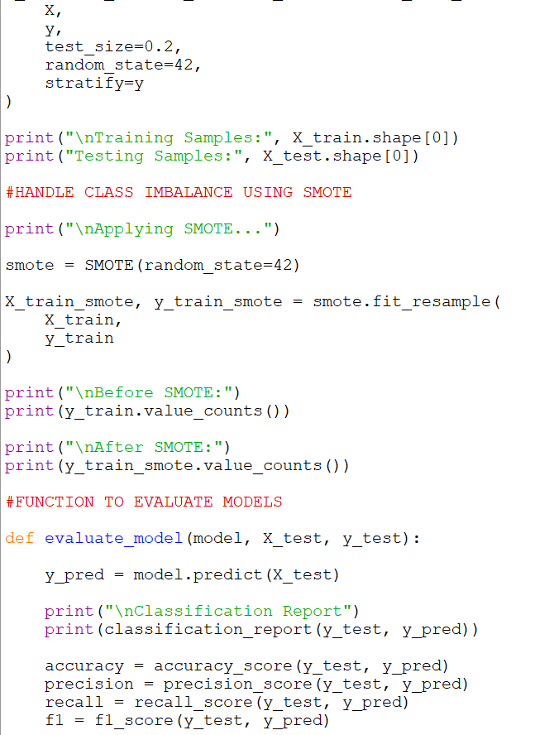

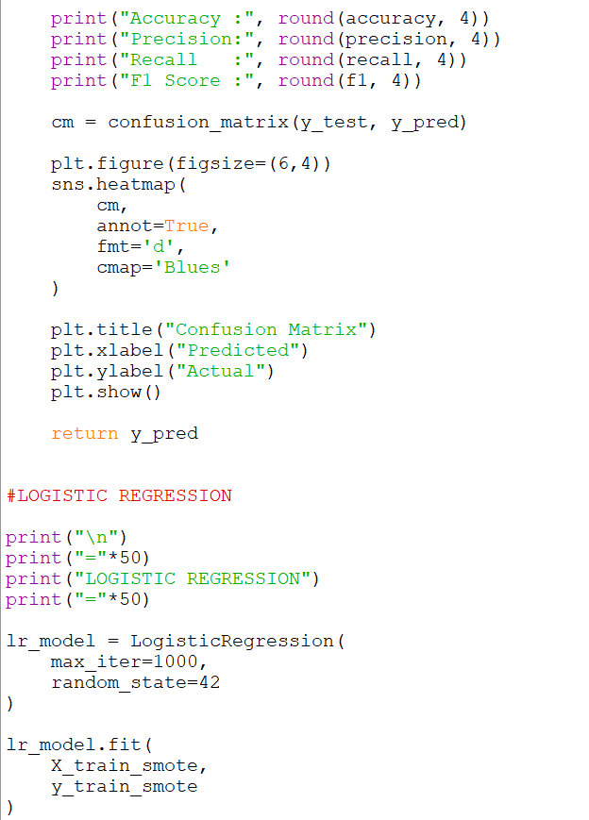

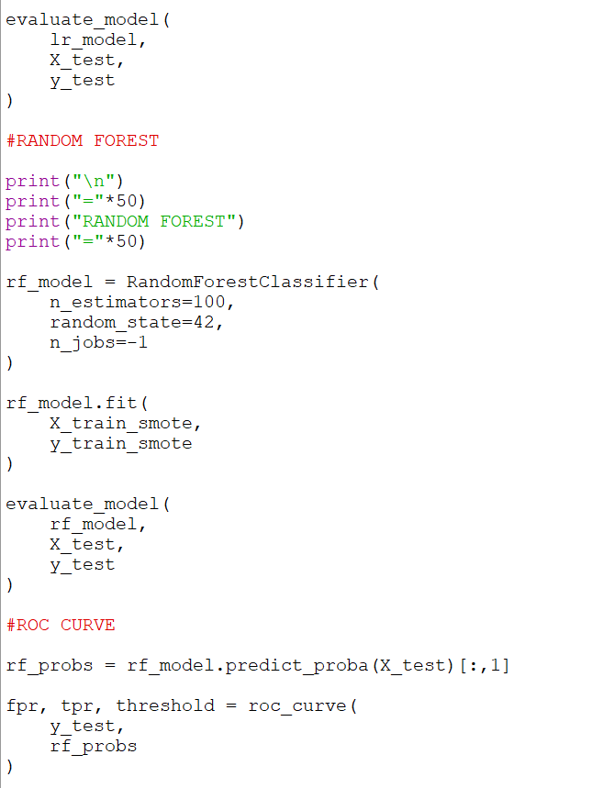

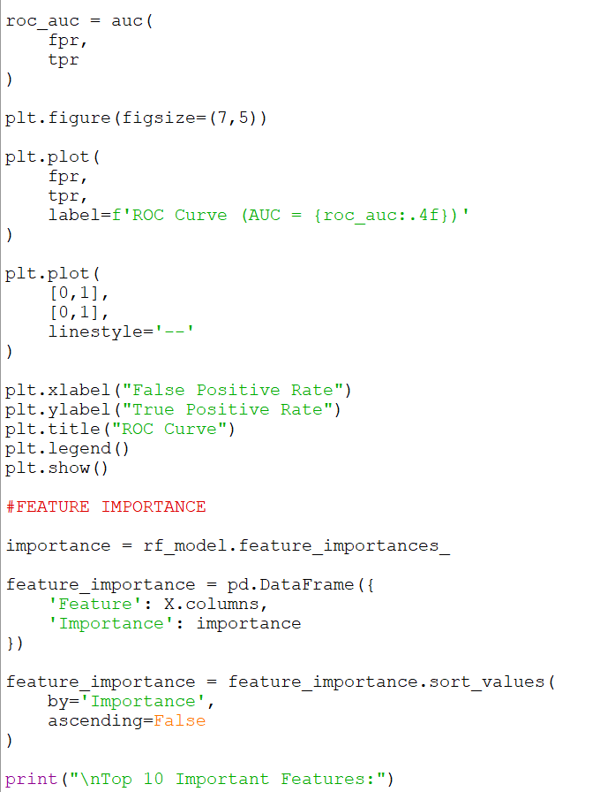

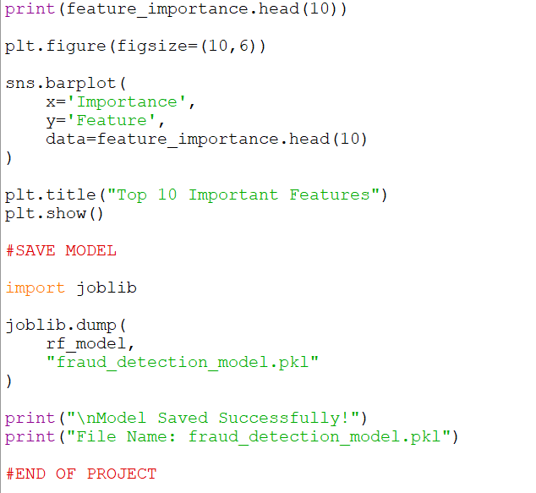

OUTPUT:

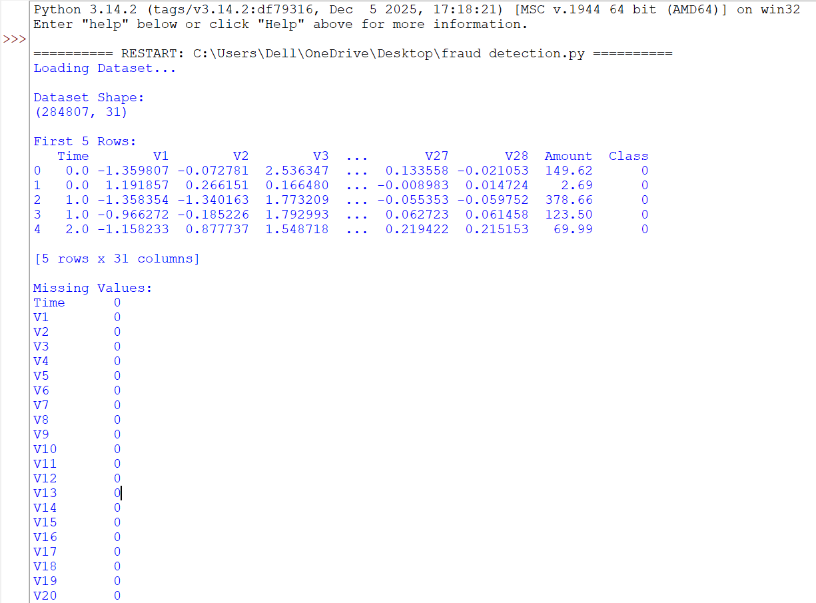

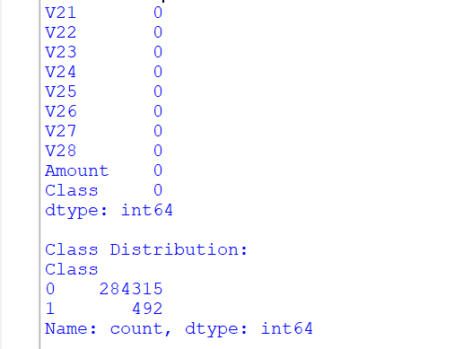

CONFUSION MATRIX:

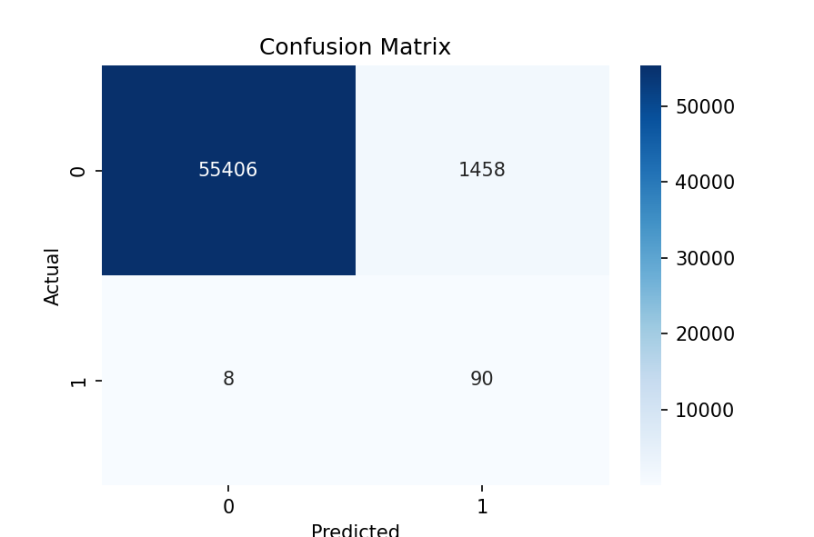

GRAPH:

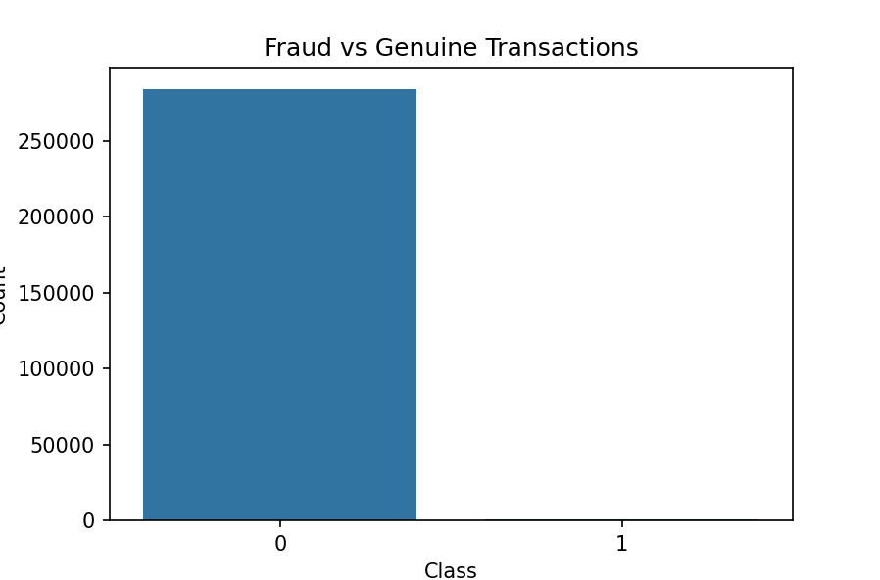

ROC GRAPH:

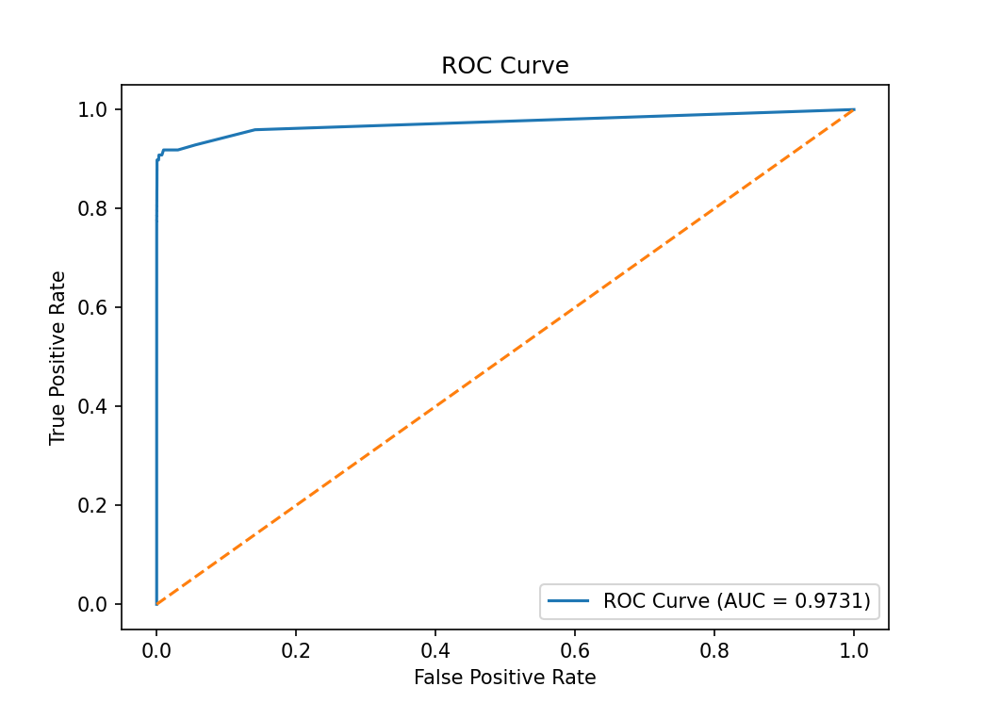

IMPORTANT FEATURES:

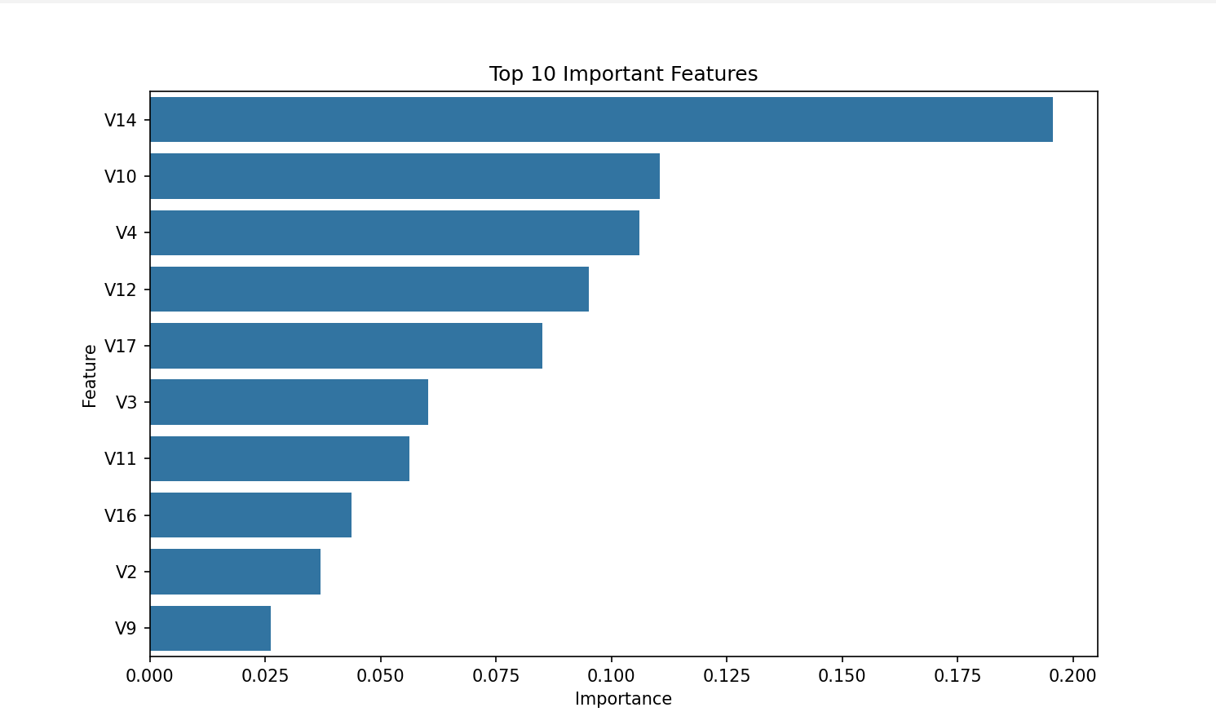

-Sadyojata Sristi

